**UNVEILING MARKETING**

**INTRODUCTION: -**

"Unveiling marketing" can refer to various strategies for introducing a product or service to the market. This might involve creating anticipation, utilizing effective communication channels, and generating excitement. If you have a specific context or question about unveiling marketing, feel free to share!

Unveiling marketing, also known as product unveiling or launch marketing, is a strategic approach used by businesses to introduce a new product or service to the market. It involves carefully planned activities and communications designed to create anticipation and generate interest among potential customers.

**Key elements of unveiling marketing may include:**

1. **Teaser Campaigns**: Building anticipation through teasers, sneak peeks, or hints about the upcoming product or service.

2. **Target Audience Identification**: Understanding the demographics, preferences, and needs of the target audience to tailor marketing efforts effectively.

3. **Multi-Channel Promotion**: Utilizing various marketing channels such as social media, email marketing, press releases, and events to reach a wide audience.

4. **Unique Selling Proposition (USP)**: Highlighting the unique features or benefits of the product that set it apart from competitors.

5. **Event Planning**: Organizing launch events, whether physical or virtual, to showcase the product and engage with potential customers.

6. **Content Creation**: Developing compelling content like videos, articles, and visuals to provide detailed information about the product.

7. **Feedback and Engagement**: Actively seeking and responding to customer feedback to improve the product and strengthen relationships.

8. **Timing and Coordination**: Ensuring that all marketing efforts are synchronized with the product's actual availability in the market.

9. **Follow-Up Campaigns**: Maintaining momentum after the initial launch by continuing to promote the product and engaging with customers.

Unveiling marketing is crucial for creating a successful market entry and can significantly impact the product's long-term success. It's a blend of creativity, market research, and strategic planning to maximize impact and customer adoption.

**OVERVIEW: -**

The conclusion of an unveiling marketing project marks the end of the planned activities surrounding the launch of a product or service. It's an important phase as it allows for reflection, evaluation, and future planning. Here are some key points to consider in concluding an unveiling marketing project:

1. **Performance Evaluation:** Analyze the metrics and KPIs (Key Performance Indicators) set at the beginning of the project. This could include factors like website traffic, social media engagement, conversion rates, and sales figures.

2. **Feedback Analysis**: Review customer feedback, both positive and negative. This can provide valuable insights into the product's reception, potential areas for improvement, and customer satisfaction levels.

3. **Budget Assessment:** Evaluate the budget allocation and expenditure. Compare actual costs with the initial budget to ensure financial targets were met.

4**. Post-Launch Impact**: Assess the product's performance post-launch. This could include measuring customer retention, repeat purchases, and overall market penetration.

5. **Lessons Learned**: Identify what worked well and what could be improved in the future. Document these lessons to apply to future marketing projects.

6. **ROI Calculation**: Calculate the Return on Investment (ROI) to determine the effectiveness of the marketing efforts. This involves comparing the gains (e.g., revenue, customer acquisition) with the costs.

7. **Stakeholder Feedback**: Gather feedback from various stakeholders involved in the project, including the marketing team, product development team, and any external partners or agencies.

8. **Documentation and Reporting**: Create a comprehensive report summarizing the project, including objectives, strategies, execution, and outcomes. This document can serve as a reference for future projects.

9. **Celebrating Successes**: Acknowledge the achievements and successes of the project team. This can help boost morale and motivation for future endeavors.

10. **Post-Launch Support**: Ensure that all necessary support or resources are in place for the ongoing success of the product in the market.

11. **Future Planning**: Consider how the insights gained from this project can inform future marketing strategies and product launches.

**PROBLEM DEFINING & DESING THINKING: -**

**1.EMPATHY MAP:**

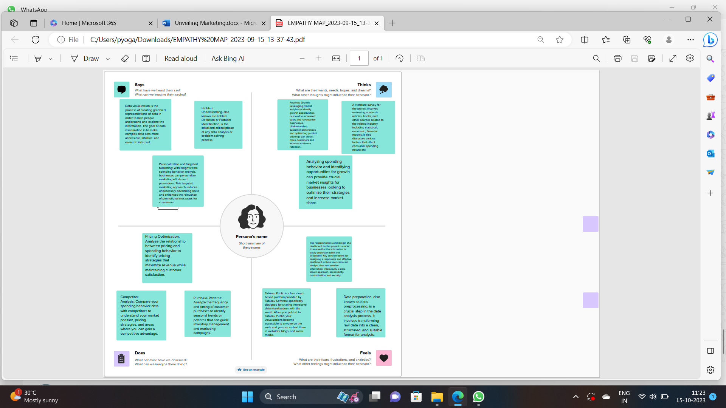

**2.IDEATION & BRAINSTROMING MAP:**

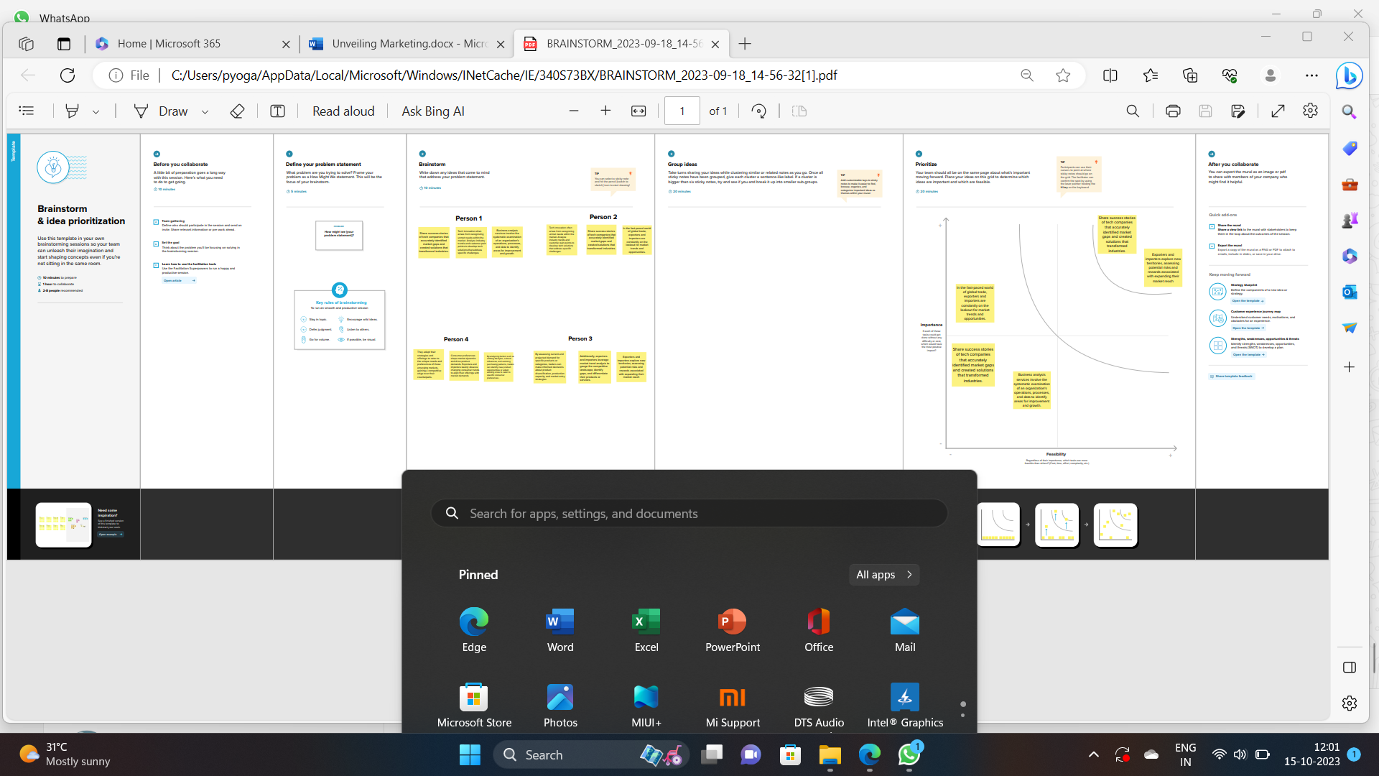

**Final Finding:** (output of the project along with the screen short)

I submitted my project in GitHub account. This is the output of the project along with the screenshot

**ADVANTAGES:**

Unveiling marketing, also known as product launch marketing, offers several advantages:

1. **Builds Anticipation**: It generates excitement and anticipation among potential customers, creating a buzz around the product.

2. **Creates Awareness**: It helps in creating awareness about the product, its features, and benefits among the target audience.

3. **Captures Initial Market Share**: A well-executed unveiling can help a product gain an initial foothold in the market, which can be crucial for long-term success.

4. **Generates Interest**: It piques the interest of potential customers, drawing them towards the product.

5. **Differentiation**: It allows a company to highlight the unique features and advantages of its product compared to competitors.

6. **Maximizes Impact**: A coordinated unveiling strategy can maximize the impact of the launch and make it more memorable for consumers.

7. **Media Coverage**: A successful unveiling can attract media attention, providing free publicity and increasing the reach of the product.

8. **Feedback Loop**: It provides an opportunity to gather feedback from early adopters, helping in refining the product or marketing strategy.

9. **Sets the Tone**: The way a product is introduced sets the tone for its entire lifecycle, influencing how it's perceived in the market.

10. **Boosts Sales**: A well-received unveiling can lead to initial sales spikes, setting a positive trajectory for future sales.

11. **Establishes Brand Image**: It contributes to shaping the brand's image and reputation, particularly for new entrants or innovative products.

12. **Encourages Brand Loyalty**: A successful unveiling can create a positive first impression, potentially leading to long-term customer loyalty.

**FUTURE SCOPE:**

The future scope of unveiling marketing is likely to evolve in several keyways:

1. Technological Integration: With advancements in technology, virtual and augmented reality experiences may become more prevalent in product unveilings, providing consumers with immersive experiences.

2. Personalization and AI-driven Insights: AI algorithms may be used to analyze consumer data, allowing for highly personalized unveiling campaigns tailored to individual preferences and behaviors.

3. Sustainability and Ethical Marketing: As environmental consciousness grows, companies may focus on sustainable product unveilings, emphasizing eco-friendly practices and ethical sourcing.

4. Interactive Experiences: Interactive elements, such as live Q&A sessions, polls, and user-generated content, could become integral to engaging audiences in real-time during product launches.

5. Social Media Dominance: Platforms like Instagram, TikTok, and other emerging social media channels may play an even more significant role in unveiling marketing, given their popularity and reach.

6. Multi-Platform Integration: Seamless integration across various platforms and devices will be crucial to ensure a consistent and engaging unveiling experience for a diverse audience.

7. Emphasis on Content Marketing: High-quality content, including videos, blogs, and interactive multimedia, will continue to be essential in conveying the value and uniqueness of the product.

8. Influencer Collaborations: Strategic partnerships with influencers and content creators could become even more prevalent, leveraging their credibility and reach to amplify the unveiling message.

9. Global Accessibility: Leveraging technology, companies may aim to make product unveilings accessible to a global audience in real-time, breaking down geographical barriers.

10. Data-Driven Insights for Continuous Improvement: Enhanced analytics and data-driven insights will play a critical role in evaluating the effectiveness of unveiling strategies and refining them for future launches.

11. Emphasis on Customer Experience: Providing an exceptional customer experience during the unveiling process will be paramount, ensuring customers feel valued and connected to the brand.

12. AI-Powered Chatbots and Virtual Assistants: These technologies may play a larger role in answering customer queries, providing instant information, and enhancing the overall unveiling experience.

Overall, the future of unveiling marketing will be shaped by technological innovations, consumer preferences, and a continued focus on creating meaningful, engaging experiences for customers. Companies that adapt and leverage these trends effectively will likely have a competitive edge in the evolving market.

**CONCLUSION:**

In conclusion, unveiling marketing holds significant strategic value in introducing a product to the market. It serves as a powerful catalyst for building anticipation, creating awareness, and differentiating a product in a competitive landscape. Through carefully orchestrated campaigns, companies can capture an initial market share and establish a strong foundation for sustained success.

As we look ahead, the future of unveiling marketing is poised for dynamic evolution. Advancements in technology, such as virtual experiences and AI-driven personalization, promise to revolutionize the way products are introduced. Sustainability and ethical considerations are becoming increasingly important, reflecting a broader societal shift towards responsible consumption.

The integration of social media, content marketing, and influencer collaborations will continue to play pivotal roles in reaching and engaging diverse audiences. Additionally, the emphasis on data-driven insights and customer-centric experiences will remain central to refining and optimizing unveiling strategies.

In this ever-changing landscape, adaptability and innovation will be key. Companies that leverage emerging trends while staying true to their brand values will be well-positioned to not only unveil products effectively but also to forge lasting connections with their customers. Unveiling marketing, as a dynamic and strategic approach, will continue to be a cornerstone in shaping the success of new product launches in the years to come.

**RESULT:**

**SHEETS:**







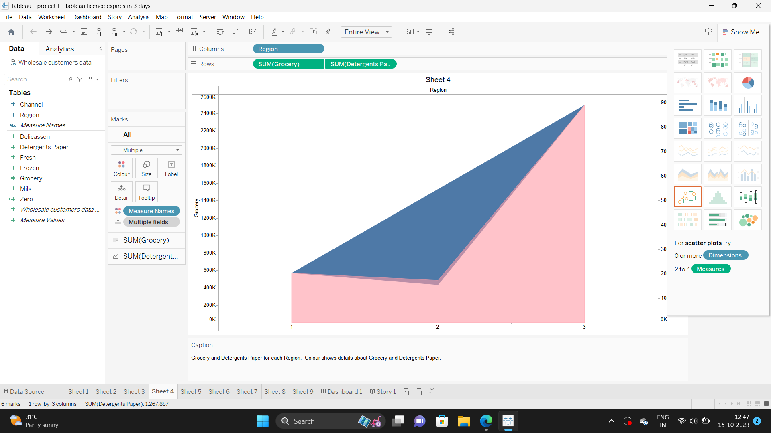





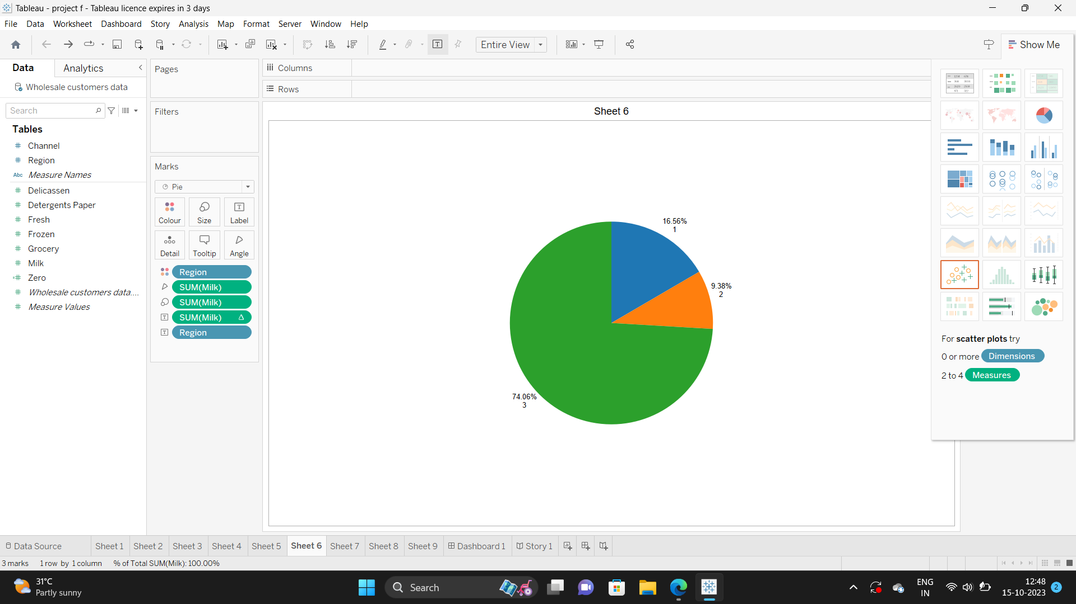

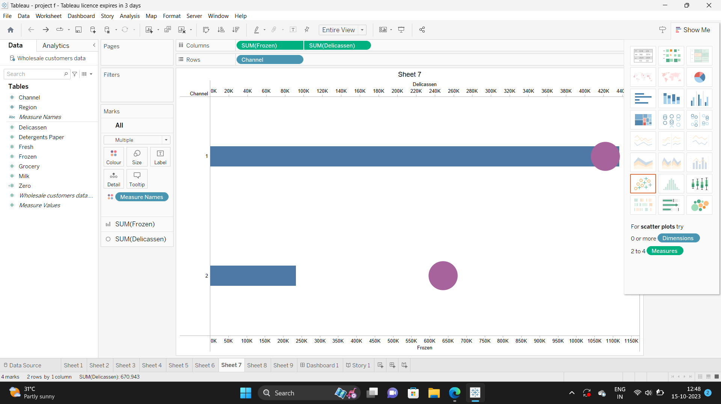

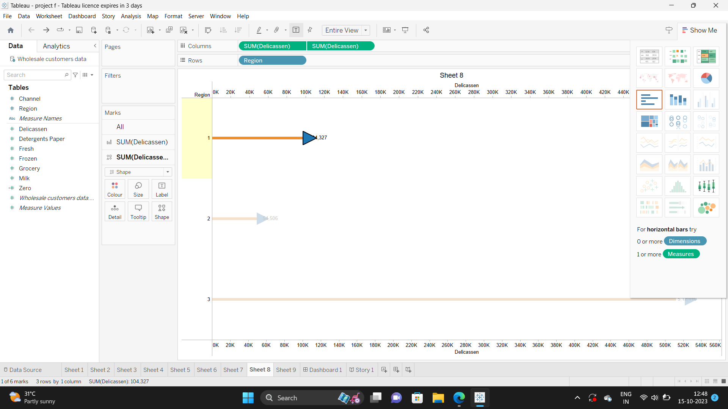

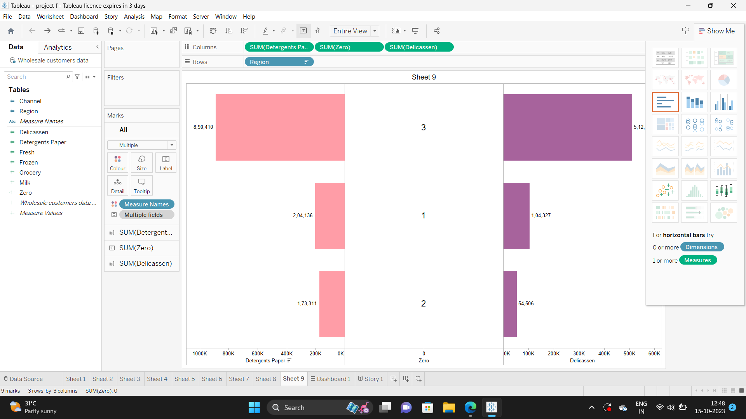

**DASHBOARD:**

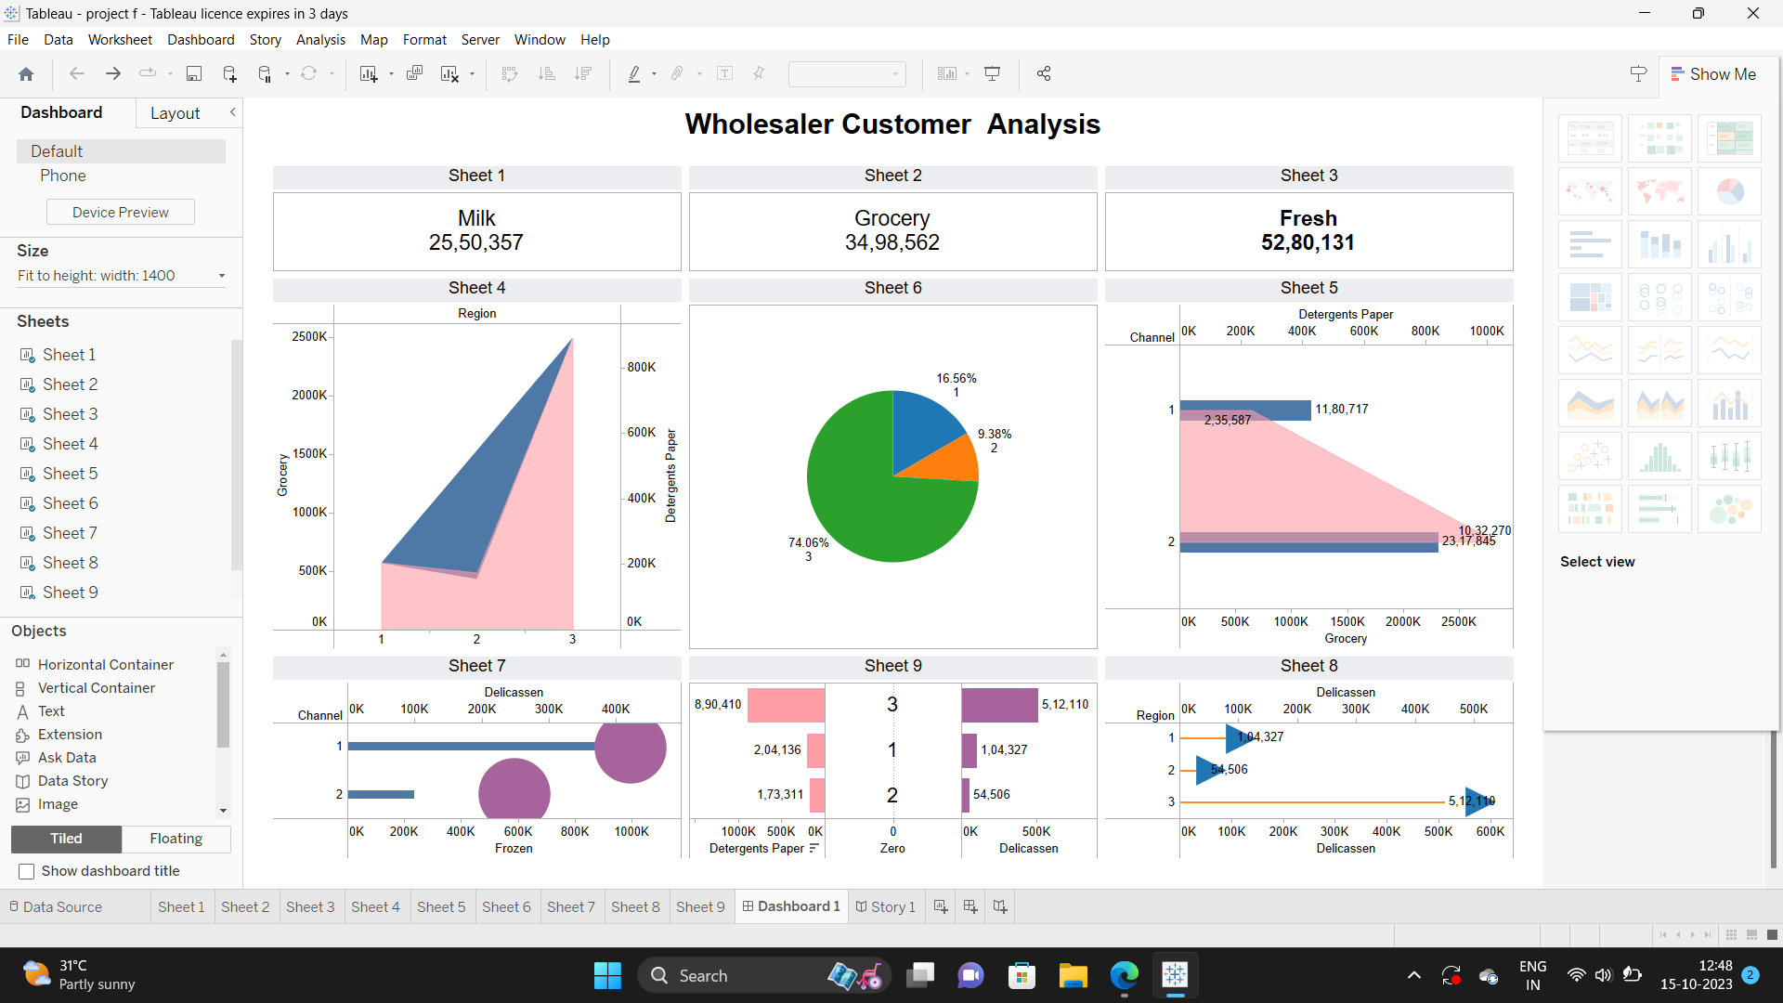

**STORY:**

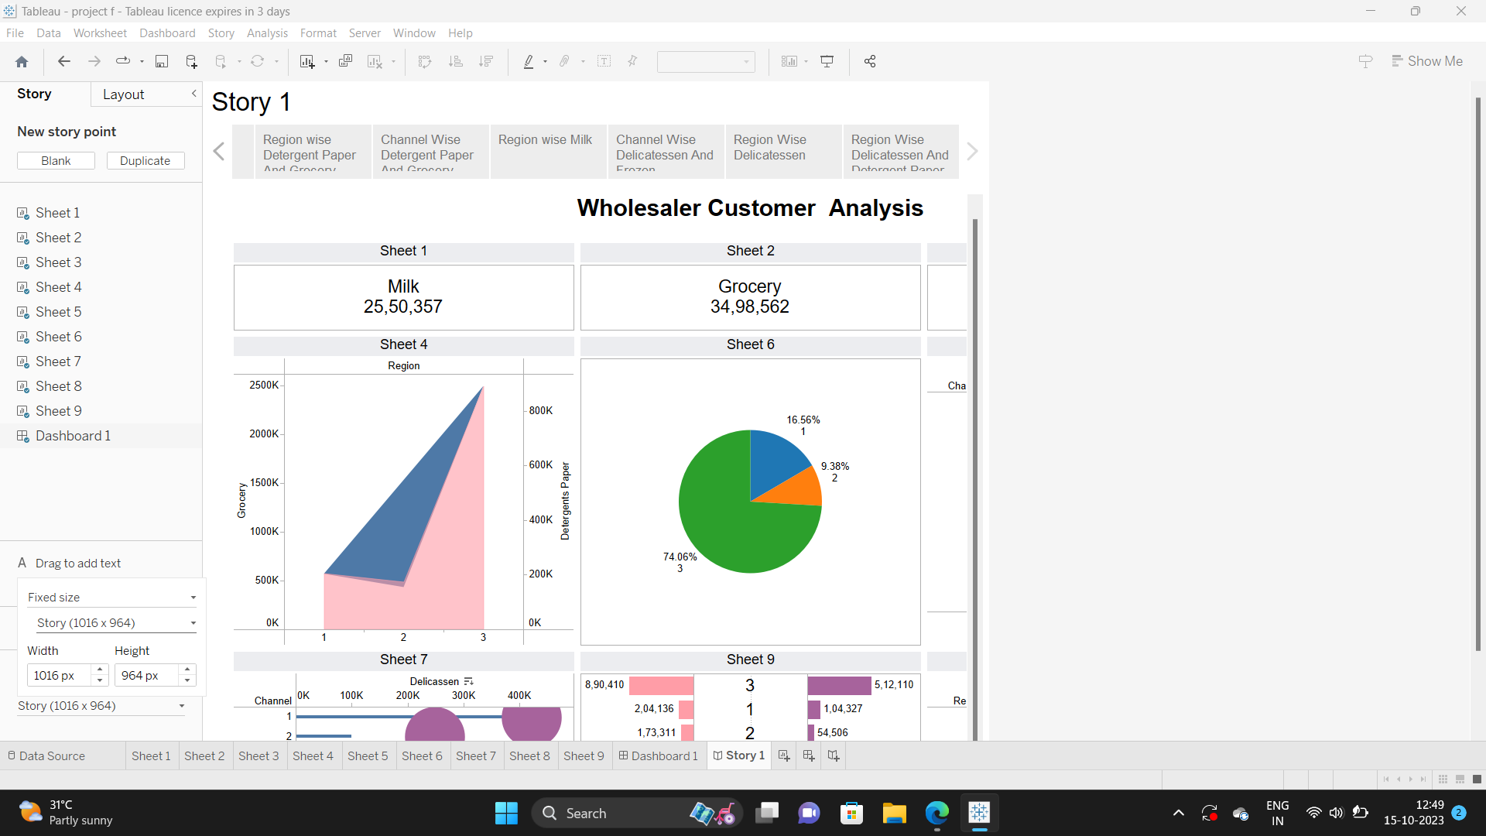

**THANK YOU ALL**